

**SAFE DRIVING REVIEW**

**SEE MORE SAFETY INFORMATION AT WWW.MODUMPTRUCK.ORG**

**Always drive safely!** Dump truckers drive on interstates and the smallest roads in Missouri. Driving can be the most dangerous task of our workday: Vehicle crashes are the most common cause of employee fatalities in the United States. Distracted driving, excessive speed, complacency and fatigue are all contributing factors in commercial vehicle crashes. Please review this Tool Box Talk with the drivers in your company. Encourage drivers to stay focused, control their emotions and stay situationally aware!

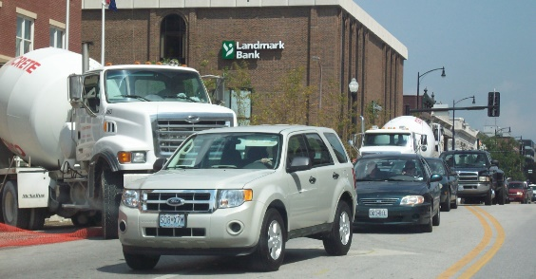

* Wear your seat belt. Your seat belt protects you in a truck crash, keeping you seated and in control.
* All riders in the truck must be seated and belted.
* Get some sleep before long days of driving. Fatigue is a major contributing factor to truck crashes. Pull over and nap if you’re falling asleep behind the wheel.
* Increase following distance and never “push” or tailgate other motorists. Your perception, reaction and brake activation time create a “lag” that can prevent you from stopping in time. Rear-end crashes are preventable.
* Don’t drive distracted. Do not text and drive. If you cause a distracted driving crash, you could personally be held civilly and/or criminally responsible. Your phone’s data use could become evidence and be used against you in a trial.
* Control other distractions like CB use, food, smoking, eating and drinking – pay attention to the road.
* Keep vehicle speeds appropriate and slow down! Speeding is a top contributing factor to dump truck crashes. Driving at a safe speed gives you time to react.
* Turn off supplemental brake systems in the rain, or when driving on wet, icy or snowy roads.
* Be aware of other motorists and assume they are driving distracted. Other drivers sometimes do not understand why you are driving slower than the traffic flow and may drive aggressively around you.
* Other motorists will tailgate you, cut you off or drive in your blind spots. Please stay situationally aware, maintain your cushion of safety and keep a safe following distance.
* Before backing up, get out and look!
* Back up safely – no faster than walking speed.
* Slow down on job sites.
* Always check your truck, including tires, before and after driving for defects and wear. Make sure brakes function properly. Check all lights.

**DON’T GET FRUSTRATED AND TAILGATE WHEN TRAFFIC GETS CONGESTED.**

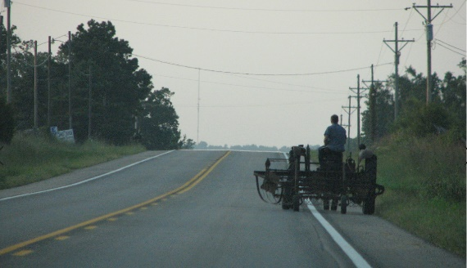

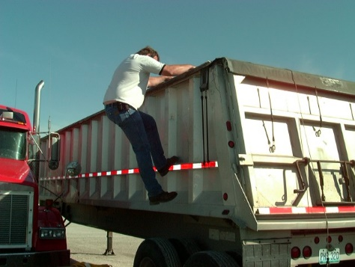

**ALWAYS SCAN AHEAD AND WATCH FOR SLOW-MOVING TRAFFIC.**

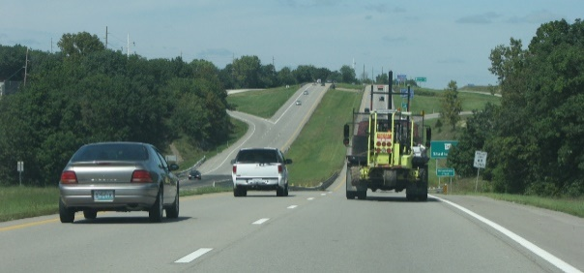

**TRY TO STAY IN THE RIGHT LANE. THIS TACTIC GIVES YOU AN “OUT” IF YOU HAVE TO STOP SUDDENLY.**

*These advisory materials have been developed from national standards and sources believed to be reliable, however, no guarantee is made as to the sufficiency of the information contained in the material and Missouri Dump Truckers Association assumes no liability for its use. Advice about specific situations should be obtained from a safety professional. 06/13/19 by MW*

*These advisory materials have been developed from national standards and sources believed to be reliable, however, no guarantee is made as to the sufficiency of the information contained in the material and Missouri Trucking Association assumes no liability for its use. Advice about specific situations should be obtained from a safety professional. 04-30-2019 by MW*

*These advisory materials have been developed from national standards and sources believed to be reliable, however, no guarantee is made as to the sufficiency of the information contained in the material and Missouri Trucking Association assumes no liability for its use. Advice about specific situations should be obtained from a safety professional. 04-30-2019 by MW*