

**SEE MORE SAFETY INFORMATION AT WWW.MODUMPTRUCK.ORG**

**New employees are at a higher risk for incident and injury.** Statistics show that up to 40% of new employees will be injured within their first year on the job. There are many reasons why new employees are injured, including poor training and supervision, poor hiring practices, an overwhelming amount of new information, or a desire to fit in. Start new employees off right by discussing safety requirements on the first day of the job!

**NEW EMPLOYEE SAFETY**

**INJURY AND INCIDENT REPORTING**

* New employees must report incidents to their supervisor by the end of the work shift.
* Report witnessed incidents to the supervisor by the end of the work shift.
* A post-incident drug and alcohol screen will be required after incidents and injuries.
* Report all incidents in writing before going home for the day.

**SEAT BELTS AND SAFE DRIVING**

* Vehicle crashes are the most common cause of employee fatalities in the U.S.
* Employees must use safety belts in vehicles or on machines equipped with safety belts.
* Employees discovered not wearing safety belts will be subject to disciplinary action.
* Distracted driving is prohibited. Do not text, dial or use phones while driving.
* Drive at a safe speed. Do not tailgate. Never push other motorists or put them at risk for a crash.
* Do not lift dump beds under power lines.
* Advise employees of fire extinguisher locations on the job site, in vehicles and in machines.

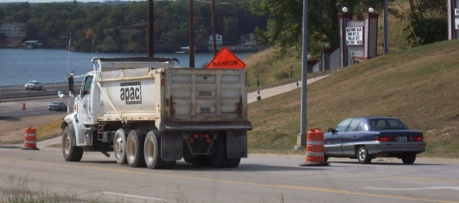

**CHAIN OF COMMAND**

* Describe the chain of command within the company.
* Who is the employee’s supervisor?
* How does the employee contact the supervisor?
* Who can the employee contact for a problem?
* Who can the employee contact to report a hazard or unsafe condition with a truck or trailer?
* Provide important cell and after-hours company phone numbers.
* Review the company’s injury/incident reporting process.
* Review all safety rules and procedures.
* Require employees to sign and date all safety policies.

**REVIEW COMMON HAZARDS OF THE JOB**

* Discuss the major dangers of the job:
  + Slips, trips and falls
  + Struck-by hazards
  + Vehicle crash
  + Loud machines
  + Heavy lifting
* Encourage the employee to take personal responsibility for their actions and make safe decisions.
* Discuss the training the employee will need on specific trucks and equipment like dry bulkers and end dumps.

**ISSUE PERSONAL PROTECTIVE EQUIPMENT**

* Provide the employee with a list of personal protective equipment (PPE) needed on the job.
* Advise the employee how to obtain PPE if theirs is lost, stolen, damaged or worn out.
* Advise of disciplinary action regarding PPE.



*These advisory materials have been developed from national standards and sources believed to be reliable, however, no guarantee is made as to the sufficiency of the information contained in the material and Missouri Dump Truckers Association assumes no liability for its use. Advice about specific situations should be obtained from a safety professional. 06/13/19 by MW*

**ALWAYS DRIVE SAFELY AND WEAR YOUR SEAT BELT!**

*These advisory materials have been developed from national standards and sources believed to be reliable, however, no guarantee is made as to the sufficiency of the information contained in the material and Missouri Dump Truckers Association assumes no liability for its use. Advice about specific situations should be obtained from a safety professional. 06/13/19 by MW*

*These advisory materials have been developed from national standards and sources believed to be reliable, however, no guarantee is made as to the sufficiency of the information contained in the material and Missouri Trucking Association assumes no liability for its use. Advice about specific situations should be obtained from a safety professional. 04-30-2019 by MW*

*These advisory materials have been developed from national standards and sources believed to be reliable, however, no guarantee is made as to the sufficiency of the information contained in the material and Missouri Trucking Association assumes no liability for its use. Advice about specific situations should be obtained from a safety professional. 04-30-2019 by MW*