

**SEE MORE SAFETY INFORMATION AT WWW.MODUMPTRUCK.ORG**

**Parking lot safety? Really? YES!** As simple as it seems, parking lot hazards cause many slips, trips and falls, which are the most common cause of driver injury. These hazards can include potholes, curbs, low lighting, rough terrain, traffic and pedestrians. No matter where you park your truck, look for these hazards and remember these safety tips!

**PARKING LOT HAZARDS**

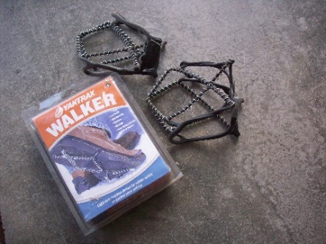

* **Slips or trips can cause falls that result in fractures, strains, sprains or even head injuries.**
* **Always be aware of your surroundings and blind spots.**
* **Don’t park your truck over potholes or fall hazards.**
* **Use a flashlight to scan the ground before exiting your truck, and when working at night.**
* **Wear proper footwear with ankle support.**
* **Do not wear flip-flops, slip-on shoes or sandals.**
* **Do not run. Horseplay is prohibited.**
* **Do not text and walk. Pay attention to your route.**
* **Use a dry tarp when performing pre-trip inspections or other work in wet, muddy, icy or snowy parking lots.**
* **Use plenty of light when performing work including hooking up to or dropping trailers.**
* **Choose the safest route when walking through job sites, work areas and parking lots.**
* **Steep inclines, ramps, steps, walls and loading docks can be slippery when wet and difficult to traverse.**
* **Pay attention to avoid slips and trips in parking lots, dumping areas and loading docks!**

**IMPROVE TRACTION WITH SLIP-ON TRACTION DEVICES.**

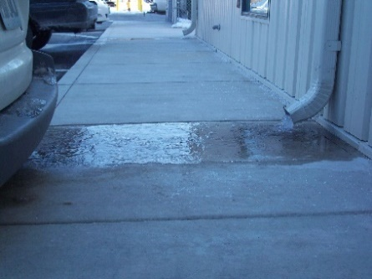

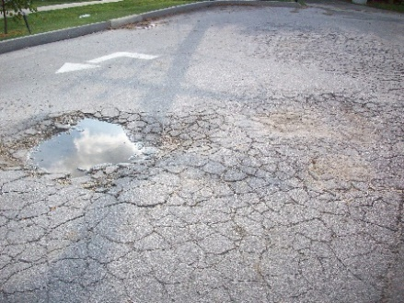

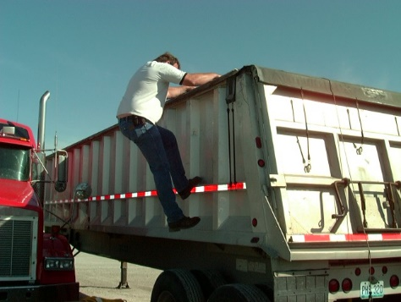



*These advisory materials have been developed from national standards and sources believed to be reliable, however, no guarantee is made as to the sufficiency of the information contained in the material and Missouri Dump Truckers Association assumes no liability for its use. Advice about specific situations should be obtained from a safety professional. 06/13/19 by MW*

**ALWAYS SCAN FOR HAZARDS LIKE ROCKS, ICE AND POTHOLES. USE A FLASHLIGHT AT NIGHT.**

*These advisory materials have been developed from national standards and sources believed to be reliable, however, no guarantee is made as to the sufficiency of the information contained in the material and Missouri Trucking Association assumes no liability for its use. Advice about specific situations should be obtained from a safety professional. 04-30-2019 by MW*

*These advisory materials have been developed from national standards and sources believed to be reliable, however, no guarantee is made as to the sufficiency of the information contained in the material and Missouri Trucking Association assumes no liability for its use. Advice about specific situations should be obtained from a safety professional. 04-30-2019 by MW*