

**We support your safety!** Falls from cabs, steps and trailers are common causes of injury for professional drivers. After a long day of driving, our legs just aren’t as strong as we’d like them to be. When your feet miss a step, or your knees are weak, a fall can injure your shoulders, knees and ankles. Bone fractures can occur in lower legs and hips. Drivers can strike their head on the way down. Take time and slow down! Remember that taking extra time to properly mount and dismount machines can keep you safe.

**THREE-POINT CONTACT**

**SEE MORE SAFETY INFORMATION AT WWW.MODUMPTRUCK.ORG**

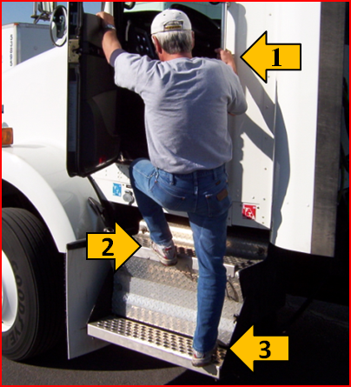

* **After driving all day, your shoulder, back and leg muscles aren’t warmed up, and are not as flexible. Your legs can give out when climbing out of the truck.**
* **Wear only lace-up work boots. Sandals and flip-flops are not acceptable footwear for drivers.**
* **Enter and exit facing the cab.**
* **Never jump down from the truck. Impact forces can injure your ankles, knees and hips.**
* **Keep a firm grip on handrails and grab handles.**
* **Use only steps and handrails provided on the truck.**
* **Clear steps of dirt, road tar, ice and diesel fuel.**
* **Keep steps clean and in good repair. Report damage and loose components.**
* **Saddle tank steps can be slick and covered with diesel fuel and mud. Clear these hazards before climbing.**
* **Don’t step out of the cab and into traffic.**
* **Avoid stepping on the diesel fill cap near saddle tank steps. Fill caps are an obstruction that can cause a slip.**
* **Maintain good foot grip. Clear mud from footwear.**
* **Survey the ground for trip hazards before exiting. Do not park over puddles, mud holes or potholes.**
* **Use a flashlight to survey the ground at night.**

**ALWAYS FACE THE CAB WHEN MOUNTING AND DISMOUNTING THE TRUCK. NEVER FACE AWAY FROM THE TRUCK AND DO NOT JUMP.**

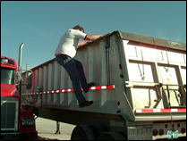

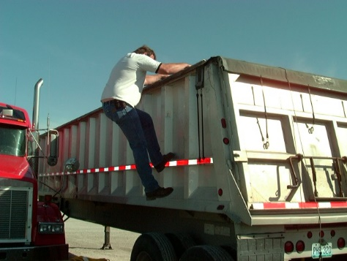

**USE ONLY PROVIDED LADDERS AND STEPS. STORE A PROPER STEP LADDER ON YOUR TRUCK IF POSSIBLE AND USE IT FOR DIFFICULT TO REACH ITEMS. A SLIP AND FALL COULD RESULT IN SERIOUS INJURIES!**



*These advisory materials have been developed from national standards and sources believed to be reliable, however, no guarantee is made as to the sufficiency of the information contained in the material and Missouri Dump Truckers Association assumes no liability for its use. Advice about specific situations should be obtained from a safety professional. 06-01-2019 by MW*

*These advisory materials have been developed from national standards and sources believed to be reliable, however, no guarantee is made as to the sufficiency of the information contained in the material and Missouri Trucking Association assumes no liability for its use. Advice about specific situations should be obtained from a safety professional. 04-30-2019 by MW*

*These advisory materials have been developed from national standards and sources believed to be reliable, however, no guarantee is made as to the sufficiency of the information contained in the material and Missouri Trucking Association assumes no liability for its use. Advice about specific situations should be obtained from a safety professional. 04-30-2019 by MW*