

**SEE MORE SAFETY INFORMATION AT WWW.MODUMPTRUCK.ORG**

**Check your tires before driving and throughout the day!** Work-related vehicle crashes are the top cause of employee fatalities in the United States. They cause severe injuries and are very costly to employers due to injury treatment, vehicle repairs, insurance premium increases and liability for damage to vehicles, buildings and people.

**Trucking company owners:** Please review this information with all your drivers to help them prevent and prepare for a tire blowout.

**STEER TIRE BLOWOUT**

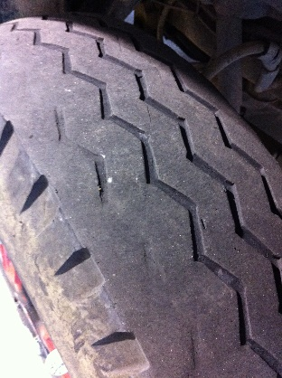

**Prevent and prepare for tire blowouts**

You can reduce the risk of steer tire blowout with better vehicle maintenance. Check tires often, especially on trucks that travel up and down gravel roads, into quarries or through rough terrain on construction sites. Do not drive a truck with bad tires, brakes or steering components!

Check tires for the following:

* Proper inflation using a tire pressure gauge
* Sidewall damage, tread separation, uneven wear and foreign object penetrations
* Tread depth consisting of 4/32” minimum tread depth on steer tires and 2/32” on rear tires
* Age of the tire
* Wheel damage, evidence of missing lug nuts or hubs, and loose components
* Steering system for excessive play, bent components, and missing nuts, bolts or pins

If a tire fails, you’ll notice the sudden sound of air loss, vibration and a heaviness in the steering wheel. It’s important not to panic. Avoid slamming on the brakes – it could cause you to lose control. Instead, maintain the vehicle’s forward momentum. Keep a firm grip on the steering wheel to avoid veering left or right. Then, find a safe place to stop the vehicle and assess the situation.

The best way to prepare is to be completely focused while driving. You should minimize distractions, pay attention and keep both hands on the steering wheel.

**UNSAFE, CUPPED TIRE FOUND ON A TRUCK. CUPPING INDICATES A WORN, UNSAFE STEERING SYSTEM.**

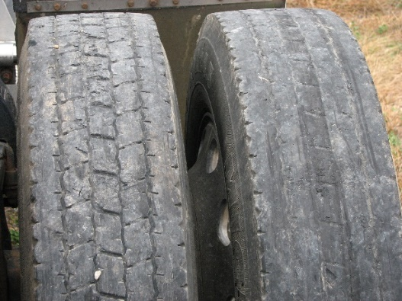

**BOTH OF THESE TIRES ARE BAD. DON’T BE COMPLACENT. ALWAYS CHECK YOUR TIRES BEFORE BEGINNING A TRIP.**



*These advisory materials have been developed from national standards and sources believed to be reliable, however, no guarantee is made as to the sufficiency of the information contained in the material and Missouri Dump Truckers Association assumes no liability for its use. Advice about specific situations should be obtained from a safety professional. 06/13/19 by MW*

*These advisory materials have been developed from national standards and sources believed to be reliable, however, no guarantee is made as to the sufficiency of the information contained in the material and Missouri Trucking Association assumes no liability for its use. Advice about specific situations should be obtained from a safety professional. 04-30-2019 by MW*

*These advisory materials have been developed from national standards and sources believed to be reliable, however, no guarantee is made as to the sufficiency of the information contained in the material and Missouri Trucking Association assumes no liability for its use. Advice about specific situations should be obtained from a safety professional. 04-30-2019 by MW*