

**OVEREXERTION INJURIES**

**SEE MORE SAFETY INFORMATION AT WWW.MODUMPTRUCK.ORG**

**Be safe, slow down and protect your body!** Orthopedic injuries are the top type of employee injury. Everything on a construction jobsite is heavy, which is a contributing factor to these injuries! Lifting, twisting, and yanking on objects can put you at risk, as can working in awkward postures. Use lifting equipment, keep things lubricated, break down the load or use excavators to help move it. Be smart and don’t risk your health while lifting!

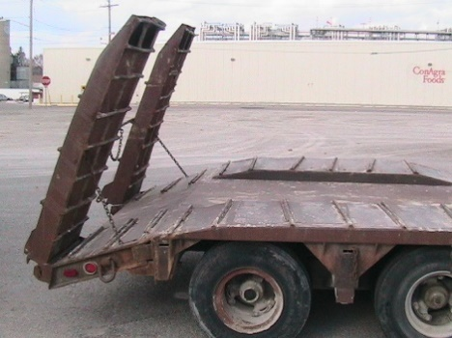

**COMMON ORTHOPEDIC INJURIES**

* Shoulders – rotator cuff tears
* Knees – cartilage meniscus tears
* Ankles – sprains and fractures
* Neck – ligament tears

**TOP CAUSES OF MUSCLE AND JOINT INJURY**

* Lifting loads that are too heavy
* Repetitive lifting
* Falling or slipping while carrying a load
* Taking shortcuts, not using proper walk paths
* Carrying bulky objects with arms outstretched
* Twisting while lifting, instead of turning once standing
* Losing grip, causing the load to shift
* Walking on uneven surfaces
* Climbing stairs while carrying heavy objects
* Lifting with the spine instead of the legs

**WHAT CAN YOU DO?**

* Break down loads. Break a case of six down to two loads of three.
* Use a machine. Can a machine on the jobsite can do the lifting for you? Skid steer, loader, pickup truck?
* Use extension cords and longer air hoses. Leave generators, welders and compressors in the truck.
* Use a wagon or dolly to move tool boxes and supplies.
* Team lift. Ask a coworker to share the load.
* When supplies are delivered, have them unloaded as close as possible to where they’re needed.
* Pick up trip hazards on stairs and walkways.
* Use gravel to make ramps over footings or concrete pad edges.
* Wear proper footwear for the jobsite – no tennis shoes.

**THINK ABOUT THE LIFT – DON’T HURT YOURSELF!**

**USE CAUTION WHEN LIFTING RAMPS, CHAINS AND BOOMERS**

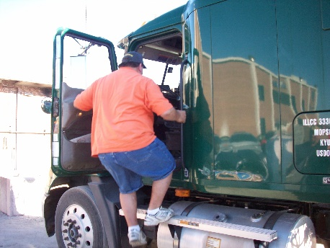

**AVOID SHOULDER AND FALL INJURIES BY USING 3-POINT CONTACT**

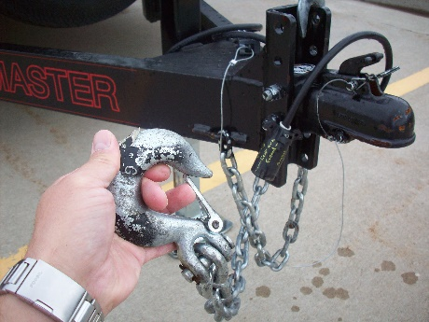



*These advisory materials have been developed from national standards and sources believed to be reliable, however, no guarantee is made as to the sufficiency of the information contained in the material and Missouri Dump Truckers Association assumes no liability for its use. Advice about specific situations should be obtained from a safety professional. 06/13/19 by MW*

**DO NOT ATTEMPT TO LIFT, YANK OR KICK HEAVY TRAILER TONGUES**

*These advisory materials have been developed from national standards and sources believed to be reliable, however, no guarantee is made as to the sufficiency of the information contained in the material and Missouri Trucking Association assumes no liability for its use. Advice about specific situations should be obtained from a safety professional. 04-30-2019 by MW*

*These advisory materials have been developed from national standards and sources believed to be reliable, however, no guarantee is made as to the sufficiency of the information contained in the material and Missouri Trucking Association assumes no liability for its use. Advice about specific situations should be obtained from a safety professional. 04-30-2019 by MW*