

**OFF-ROAD RECOVERY**

**Manage your speed, minimize distractions and pay attention when driving your truck on roads with minimal shoulder.** Many drivers will inadvertently allow their right-side tires to fall off the pavement edge. When this happens, they often panic, yank the steering wheel and slam on the brakes. This causes the vehicle to veer sharply to the left, usually resulting in an overturned vehicle or head-on crash. You can reduce or eliminate the risk of this type of crash with basic defensive driving techniques.

**SEE MORE SAFETY INFORMATION AT WWW.MODUMPTRUCK.ORG**

Don’t panic! Don’t yank the wheel!

Overcorrection crashes occur when a driver veers off the edge of the road and, in response, turns the vehicle sharply in the opposite direction.

Overcorrecting could cause you to cross the center line, slide out of control, tip over or strike another vehicle.

Often, overcorrection is caused or exacerbated when the driver strongly brakes after veering off-road.

In this case, the tires are braking on two different surfaces: the pavement of the road and gravel, grass or mud on the roadside. This decreases your control of the vehicle.

If you do veer off the road, simply take your foot off the accelerator. Keep a firm grasp on the steering wheel and guide your vehicle gradually back into the lane.

* Don’t panic, yank the wheel or jam on the brakes.
* Take your foot off the gas.
* Gently make slight corrections to your steering and guide your vehicle back onto the pavement.

Of course, a better plan is to avoid veering off-road in the first place.

* Drive at speeds appropriate for road conditions.
* Reduce your speed on curvy roads, rural roads with narrow shoulders or gravel surfaces.
* Minimize distractions in the truck and focus on the road.
* Scan for and avoid pavement drop-offs.
* Slow down when heading into curves and down hills.

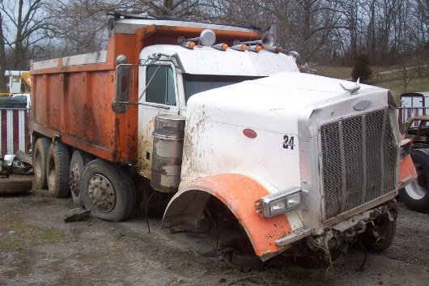

**THE DRIVER OF THIS TRUCK WAS INJURED AFTER IT RAN OFF THE RIGHT SIDE OF THE ROAD, STRIKING A DRAINAGE PIPE.**

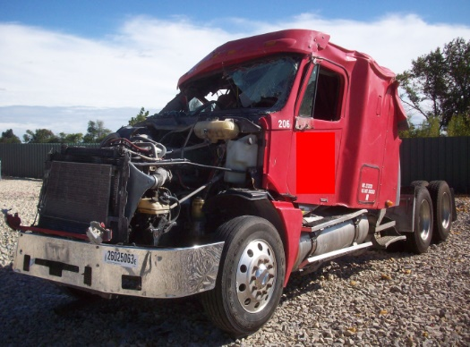

**THIS TRUCK WAS PULLING AN END DUMP TRAILER, RAN OFF THE RIGHT SIDE OF THE ROAD AND TIPPED OVER. THE DRIVER WAS WEARING A SEAT BELT AND WAS UNINJURED.**

*These advisory materials have been developed from national standards and sources believed to be reliable, however, no guarantee is made as to the sufficiency of the information contained in the material and Missouri Dump Truckers Association assumes no liability for its use. Advice about specific situations should be obtained from a safety professional. 06/13/19 by MW*

*These advisory materials have been developed from national standards and sources believed to be reliable, however, no guarantee is made as to the sufficiency of the information contained in the material and Missouri Trucking Association assumes no liability for its use. Advice about specific situations should be obtained from a safety professional. 04-30-2019 by MW*

*These advisory materials have been developed from national standards and sources believed to be reliable, however, no guarantee is made as to the sufficiency of the information contained in the material and Missouri Trucking Association assumes no liability for its use. Advice about specific situations should be obtained from a safety professional. 04-30-2019 by MW*