

**DUMP TRUCK SAFETY**

**SEE MORE SAFETY INFORMATION AT WWW.MODUMPTRUCK.ORG**

**Please be safe!** Operating a dump truck is a rough job. Days can be long, hot, cold, dusty, wet and muddy. But no matter how the weather is treating you, or how long you’ve been on the job – your safety and the safety of the other drivers is a top priority. Even if you’re tired and frustrated, don’t let your emotions or fatigue take over. Always operate your truck in a controlled manner, be mindful of traffic and work area hazards, and keep your eyes peeled for sudden changes that can catch you off guard!

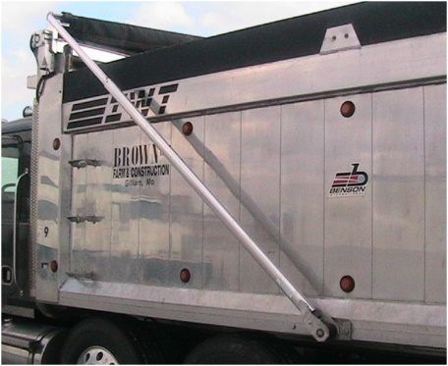

* **Wear your seat belt – it protects you in a truck crash.**
* **Make sure all riders in the truck are seat belted.**
* **Increase following distance. Don’t tailgate others.**
* **Don’t drive distracted. Do not text and drive.**
* **Control distractions and pay attention to the road.**
* **Keep vehicle speeds appropriate and slow down.**
* **Before backing, get out and look.**
* **Back safely – no faster than walking speed.**
* **Slow down on job sites.**
* **Always do your daily walk-around safety check.**
* **Make sure tires are properly inflated and safe.**
* **Keep windows clean and mirrors adjusted.**
* **Keep warning equipment, alarms and lighting working.**
* **When working alongside moving traffic, use road cones and wear a high-visibility vest.**
* **Use the safety prop rod when working under the bed.**
* **Scan for overhead power lines before raising the bed.**
* **Use 3-point contact when entering and exiting the cab.**
* **Never jump down from the truck cab or steps.**
* **To warn others, honk air horns before backing.**
* **Keep a fire extinguisher and first aid kit on hand.**
* **Know emergency phone numbers.**

**DON’T USE TARP SYSTEMS UNDER OVERHEAD POWER LINES.**

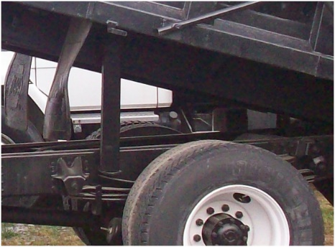

**USE PROP BARS OR SUPPORT STANDS WHEN WORKING BENEATH RAISED DUMP BEDS.**

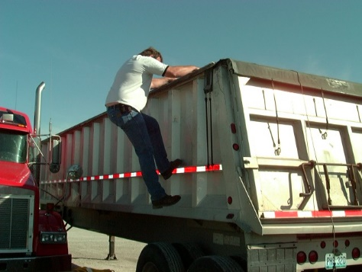

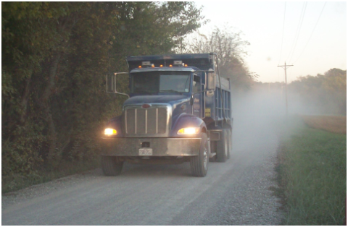



*These advisory materials have been developed from national standards and sources believed to be reliable, however, no guarantee is made as to the sufficiency of the information contained in the material and Missouri Dump Truckers Association assumes no liability for its use. Advice about specific situations should be obtained from a safety professional. 06/13/19 by MW*

**WHEN ON RURAL ROADS, PAY ATTENTION, SLOW DOWN AND AVOID RUNNING OFF THE RIGHT SIDE OF THE ROAD.**

*These advisory materials have been developed from national standards and sources believed to be reliable, however, no guarantee is made as to the sufficiency of the information contained in the material and Missouri Trucking Association assumes no liability for its use. Advice about specific situations should be obtained from a safety professional. 04-30-2019 by MW*

*These advisory materials have been developed from national standards and sources believed to be reliable, however, no guarantee is made as to the sufficiency of the information contained in the material and Missouri Trucking Association assumes no liability for its use. Advice about specific situations should be obtained from a safety professional. 04-30-2019 by MW*