

**SEE MORE SAFETY INFORMATION AT WWW.MODUMPTRUCK.ORG**

**Never report to work with illicit drugs, misused prescription medications or alcohol in your system!** If you come to work with alcohol or illicit drugs in your system, you are putting yourself and your coworkers in serious danger.

This employer is a drug-free workplace. You may be subject to tests like new hire, post-incident, random and reasonable suspicion. Violations will result in corrective action up to and including termination.

**DRUG-FREE WORKPLACES**

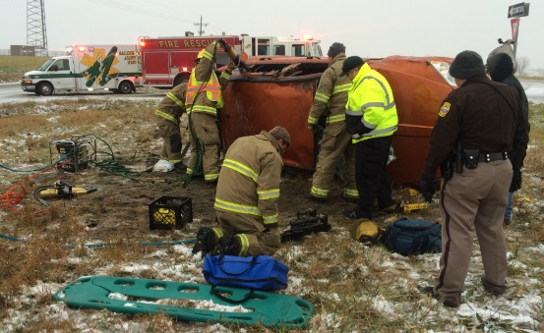

* Employees that report to work with alcohol or illicit drugs in their system are more likely to have workplace incidents.
* Injuries sustained by employees under the influence cost the company twice as much as injuries sustained by workers free of the effects of drugs and alcohol.
* Theft, assaults, absenteeism and low-quality work are also problems associated with drug use.
* This employer has developed a drug-free workplace policy that includes language on illicit drugs, illegally-used prescription medications and alcohol.
* If you suspect that a coworker is using illicit drugs or drinking alcohol on the job – or if they’re suffering from the aftereffects of substance use – report it to management immediately.
* Company drug tests typically screen for the following:
  1. Cannabis (marijuana)
  2. Cocaine
  3. Amphetamines (methamphetamine)
  4. Opioids (heroine, morphine)
  5. Barbiturates
  6. Benzodiazepines
  7. Phencyclidine (PCP)
  8. Methaqualone
  9. Methadone
  10. Propoxyphene
* A hangover may mean you are still under the influence. You may be dehydrated and fatigued, as well. A breathalyzer is used for an alcohol screen.
* Do not report to work if you’re under the influence of, or have used alcohol, or if you have drug metabolites in your system.
* Do not perform safety-sensitive jobs when you’ve been prescribed a medication with warnings that prohibit driving or using equipment.

**ACCORDING TO MISSOURI STATE HIGHWAY PATROL CRASH STATISTICS, IMPAIRED DRIVING CONTRIBUTES TO 40% OF FATALITY CRASHES IN OUR STATE.**

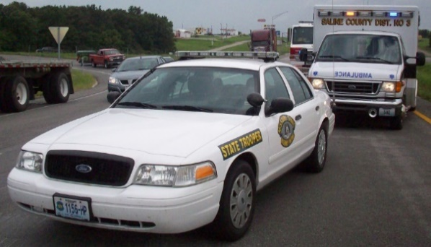

**ALCOHOL AND DRUG USE CAN RESULT IN SERIOUS INJURIES AT WORK. DIAL 911 FOR AMPUTATIONS, CRASHES AND SEVERE BLEEDING.**

*These advisory materials have been developed from national standards and sources believed to be reliable, however, no guarantee is made as to the sufficiency of the information contained in the material and Missouri Trucking Association assumes no liability for its use. Advice about specific situations should be obtained from a safety professional. 04-30-2019 by MW*

*These advisory materials have been developed from national standards and sources believed to be reliable, however, no guarantee is made as to the sufficiency of the information contained in the material and Missouri Trucking Association assumes no liability for its use. Advice about specific situations should be obtained from a safety professional. 04-30-2019 by MW*



*These advisory materials have been developed from national standards and sources believed to be reliable, however, no guarantee is made as to the sufficiency of the information contained in the material and Missouri Dump Truckers Association assumes no liability for its use. Advice about specific situations should be obtained from a safety professional. 06/13/19 by MW*

