

**Guard against complacency, fatigue, distraction and hurried work.** Good employees can develop unsafe behaviors and habits that increase their risk of personal injury or crash. Understand when, why and how pressure and stress can cause you to work in an unsafe manner. Make a personal decision to avoid unsafe conditions like poor or worsening health, letting your truck fall into disrepair, complacency, fatigue, and rushing through work. These are all contributing factors to driver injury and truck crash.

**BE READY FOR SAFE WORK**

**SEE MORE SAFETY INFORMATION AT WWW.MODUMPTRUCK.ORG**

**Top Reasons for Commercial Truck Crash**

1. Speeding
2. Distracted driving or inattention
3. Following too close
4. Failure to yield
5. Improper lane change

* Get plenty of rest. At home, try to create an environment that encourages sleep. Put your phone away and avoid sugar and caffeine in the evening. Try your best to get quality sleep before long days of driving.
* Avoid excessive alcohol consumption before long days of work. Alcohol is a depressant and a diuretic, which dehydrates you.
* Drug use is prohibited, including illegally used prescription medication. Do not report to work with these substances in your body.
* Eat well and protect your health. Heavy meals and processed foods can leave you groggy. Eat plenty of vegetables and fruit, and drink plenty of water throughout the day.
* Don’t leave your truck for the night without doing a post-trip inspection. Maintenance or safety concerns that haven’t been addressed will still be there in the morning, when you’re more likely to ignore safety concerns and drive the truck in an unsafe condition.
* Check your truck before heading out for the day. Check brakes, tires, lights and fluids before heading out. Never drive a truck with tire or brake problems.
* Check your attitude. Don’t drive aggressively. Avoid using your phone and don’t tailgate other vehicles. Never put others at risk because you’re having a bad day. Your unsafe driving could injure a family or children.

**ASK YOURSELF:**

* Are you rested, focused and ready for a safe day of work?
* Can you safely drive the truck issued to you?
* Has anything out of the ordinary happened today?
* Do you have an incident or injury to report?

**Top Types of Employee Injury**

1. Slip, trip and fall
2. Overexertion
3. Vehicle crash
4. Cuts, punctures, scrapes
5. Burns or scalds

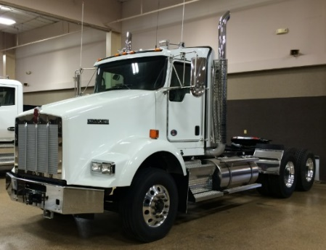

**MISSING THE SMALL THINGS COULD GET YOU IN BIG TROUBLE. MAKE SURE YOU’RE RESTED, AND THE TRUCK IS PRE-TRIP CHECKED! ALWAYS WEAR YOUR SEAT BELT, STAY OFF THE PHONE, NEVER TAILGATE AND DRIVE AT A SAFE SPEED.**

*These advisory materials have been developed from national standards and sources believed to be reliable, however, no guarantee is made as to the sufficiency of the information contained in the material and Missouri Dump Truckers Association assumes no liability for its use. Advice about specific situations should be obtained from a safety professional. 06/13/19 by MW*

*These advisory materials have been developed from national standards and sources believed to be reliable, however, no guarantee is made as to the sufficiency of the information contained in the material and Missouri Trucking Association assumes no liability for its use. Advice about specific situations should be obtained from a safety professional. 04-30-2019 by MW*

*These advisory materials have been developed from national standards and sources believed to be reliable, however, no guarantee is made as to the sufficiency of the information contained in the material and Missouri Trucking Association assumes no liability for its use. Advice about specific situations should be obtained from a safety professional. 04-30-2019 by MW*