

**SEE MORE SAFETY INFORMATION AT WWW.MODUMPTRUCK.ORG**

**Distractions caused by cellphones, social media and endless text messages contribute to injuries and damage!** Drivers, operators and other construction workers are endlessly distracted with their phones while working, running machines or driving. Distractions are a top cause of motor vehicle crashes in Missouri. Many employees are also injured on job sites because of cellphone use while working. Please review this document with employees and require limited distractions while driving and working.

**AVOIDING DISTRACTED WORK**

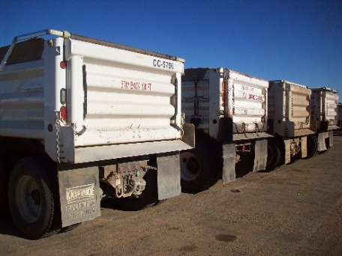

* Never drive distracted.
* Never use smartphone features that take your eyes off the road, hands off the steering wheel or mind off driving.
* Store your phone completely out of arms’ reach. Only use Bluetooth to receive calls when it is safe to do so. Pull the truck over and stop if you need to use your cellphone, text, or use a smartphone feature.
* According to the National Safety Council, there are three types of distractions that negatively affect driver safety:

1. **Visual distractions** take your eyes from the road. This includes texting, dialing a phone, using apps, reading or programming GPS units.
2. **Manual distractions** take your hands off the steering wheel. These distractions include eating, drinking, dialing a phone or using smartphone features.
3. **Cognitive distractions** take your mind off the driving task. These distractions can include daydreaming, stress, having intense conversations or cellphone conversations.

* Cellphones are dangerous because they combine all three types of distraction.
* Your phone could be confiscated after a crash, and phone data can be analyzed. Truck electronic control module (ECM) data can also be investigated. Together, data could show that a driver was distracted and driving too fast, contributing factors to a major crash. Civil and criminal penalties could result if you’ve caused a crash.
* When on a job site, highway work zone or parking lot, do not use your phone. Never use your phone for personal reasons in a safety-sensitive work environment.

**NEVER BACK A TRUCK WHILE USING A CELL PHONE. DO NOT USE A PHONE WHEN WORKING NEAR MOVING EQUIPMENT.**

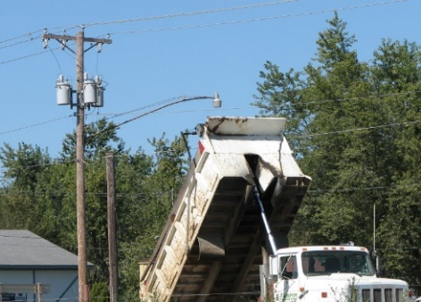

**DISTRACTIONS COULD LEAD TO CATASTROPHE. STAY AWARE OF OVERHEAD POWER LINES!**

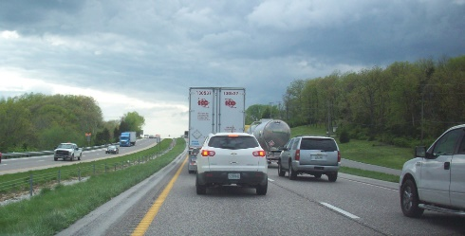

**DISTRACTIONS CONTRIBUTE TO TERRIBLE REAR-END COLLISIONS.**

*These advisory materials have been developed from national standards and sources believed to be reliable, however, no guarantee is made as to the sufficiency of the information contained in the material and Missouri Dump Truckers Association assumes no liability for its use. Advice about specific situations should be obtained from a safety professional. 06/13/19 by MW*

*These advisory materials have been developed from national standards and sources believed to be reliable, however, no guarantee is made as to the sufficiency of the information contained in the material and Missouri Trucking Association assumes no liability for its use. Advice about specific situations should be obtained from a safety professional. 04-30-2019 by MW*

*These advisory materials have been developed from national standards and sources believed to be reliable, however, no guarantee is made as to the sufficiency of the information contained in the material and Missouri Trucking Association assumes no liability for its use. Advice about specific situations should be obtained from a safety professional. 04-30-2019 by MW*