

**Why do people get injured at work? This is a very important list!** When asked, “Why do workers have incidents?” these are the responses employees gave during safety meetings. By being self-aware and paying attention to how you are working, you can intervene when these unsafe behaviors, thoughts and feelings begin to take over, and avoid damaged equipment or personal injury. If you notice any of these scenarios while working, take a break for five minutes, clear your mind, and finish your work safely.

**WHY DRIVERS GET HURT**

**SEE MORE SAFETY INFORMATION AT WWW.MODUMPTRUCK.ORG**

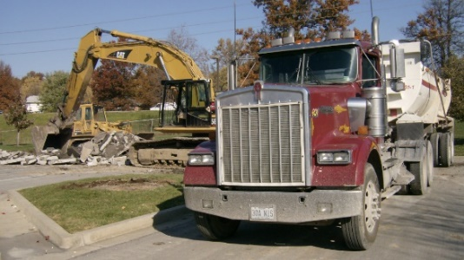

**MINDSET**

* Employees get in a hurry or just want the job done
* Fast work pace in general
* Not aware of the hazards
* Tunnel vision – focused on getting the work done
* Too lazy to do the right thing
* Complacency – too comfortable with a daily routine
* The idea that “accidents can’t happen to me”
* Overconfidence
* Careless – employee does not care about doing good work
* Only focused on themselves and not others

**TOOLS AND EQUIPMENT**

* Lack of machine, tool, job or process training
* Lack of proper safety equipment or gear
* Wrong choice of equipment, truck or tool
* Faulty equipment due to misuse, wear, abuse or age
* Tight budget or concerned about spending money

**DISTRACTIONS**

* Tired or fatigued
* Distracted by phones
* Preoccupied by stress like conflicts at home
* Absent-minded, daydreaming
* Drug and alcohol use, hangover, dehydration
* Not physically capable of doing the job

STAY AWARE OF THESE RISK FACTORS WHEN YOU ARE WORKING ALONE OR WITH GROUPS!

When you are concerned these issues may result in injury or damage, take a break to have a quick safety meeting with your group, or take the time to personally re-focus on safety.

**EVERY SINGLE WORK AREA OR CONSTRUCTION JOB SITE HAS HAZARDS. PLEASE PAY ATTENTION!**

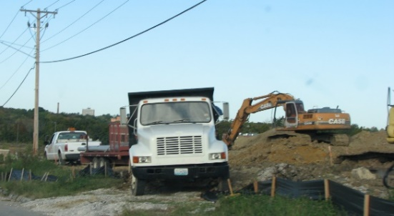

**ALWAYS SURVEY FOR OVERHEAD POWER LINES. NEVER PARK OR DUMP THE TRUCK NEAR OVERHEAD LINES.**

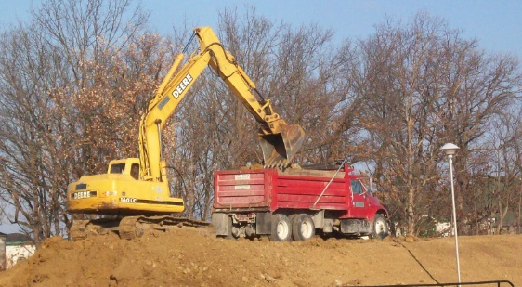

**BE SAFE WHEN BACKING.**

**USE THREE POINT CONTACT WHEN STEPPING DOWN FROM THE CAB.**

*These advisory materials have been developed from national standards and sources believed to be reliable, however, no guarantee is made as to the sufficiency of the information contained in the material and Missouri Dump Truckers Association assumes no liability for its use. Advice about specific situations should be obtained from a safety professional. 06/13/19 by MW*

*These advisory materials have been developed from national standards and sources believed to be reliable, however, no guarantee is made as to the sufficiency of the information contained in the material and Missouri Trucking Association assumes no liability for its use. Advice about specific situations should be obtained from a safety professional. 04-30-2019 by MW*

*These advisory materials have been developed from national standards and sources believed to be reliable, however, no guarantee is made as to the sufficiency of the information contained in the material and Missouri Trucking Association assumes no liability for its use. Advice about specific situations should be obtained from a safety professional. 04-30-2019 by MW*